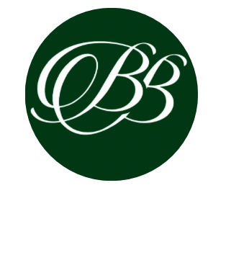
TERMS AND CONDITIONS

“The Organiser” Jen, Abbots Road, Bristol BS15 3NS, Telephone number: 07766031616, Email: contact@brightatbickley.com
“Client” The person or persons who have entered into this agreement with the Event Organiser.
- These Terms and Conditions are incorporated together with the financial terms as set out on the Invoice. There can be no variation of these Terms and Conditions, or the financial terms as set out in the invoice without the express written consent of The Organiser. It is the duty of the Client to ensure that they have read and understood these Terms and Conditions before paying the invoice.
- The Organiser reserves the right to cancel any booking without liability on its part in the event of any damage or destruction of the event premises by fire or other causes, strikes, power cuts or blackouts, pandemics or any other cause beyond the control of Bright@Bickley which shall prevent it from performing its obligations in connection with any booking.
- Once the Clients completed booking form has been received, we aim to contact the client within 24 hours to confirm availability. Once The Organiser has confirmed availability, a non-refundable 50% deposit is required within 48 hours to confirm the booking. If the payment is not made within this time, please email us to get confirmation of availability before any payment is made.
- If the account is not paid 14 days prior to the event, The Organiser reserves the right to cancel your event and the deposit will be forfeited.
- The client shall be responsible for checking the measurements of all items ordered so that they fit in the space in which they would like the props to be placed, The organiser cannot be held responsible for incorrect space measurements.
- It is the clients responsibility to check with the venue for the best position of the props to ensure this is close to an electricity supply. If more than 6 letters/numbers have been ordered, please check with the organiser in regards to the electricity output needed.
- Once the Client has paid the deposit, no change to the date of the event will be permitted without the express written consent of The Organiser.
- Failure to pay all invoices on time could lead to the cancellation of the order.
- In the event of cancellation, the booking deposit is non-refundable.
- Participants, both children, and adults, are prohibited from climbing on or tampering with props and any LED lights.
- LED items should not be placed near water sources to prevent electrical hazards.
- If used outdoors, alternative coverage must be arranged for protection against adverse weather conditions.
- The Client is responsible for any damages incurred during the rental period.
- Once delivered, all items become the sole responsibility of the The Client.
- Any damages, losses, or accidents occurring during the event are The Client's responsibility.
- By agreeing to these terms and conditions, The Client/s acknowledge their responsibility for the proper handling and care of rented items and agree to adhere to safety guidelines outlined herein.
This list is not exhaustive and may change at any time without notice. These Terms & Conditions should be read in conjunction with the Booking Form.

Bright@Bickley, Abbots Road, Hanham Abbots, Bristol, BS15 3NS
Telephone Jen: 07766031616 Email: contact@brightatbickley.com

Revised: 18.03.2024

